JOB TRACKING SYSTEM

-Venkat Nikhil M

1. LOGIN PAGE

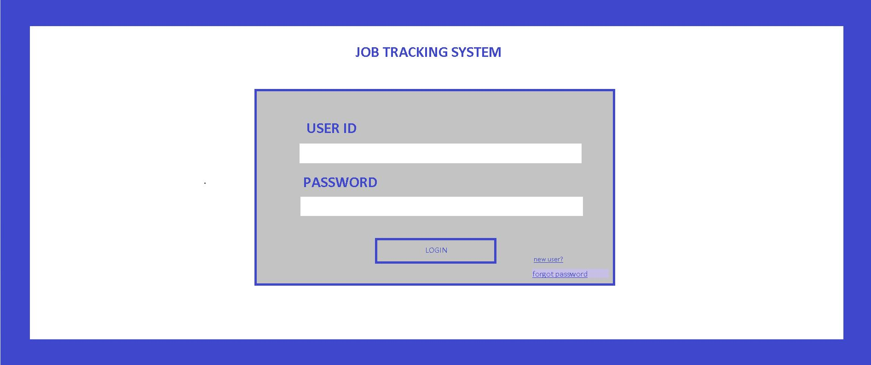

Enter login details. If new user, press new user link. This will direct the user to the next page

1. User details

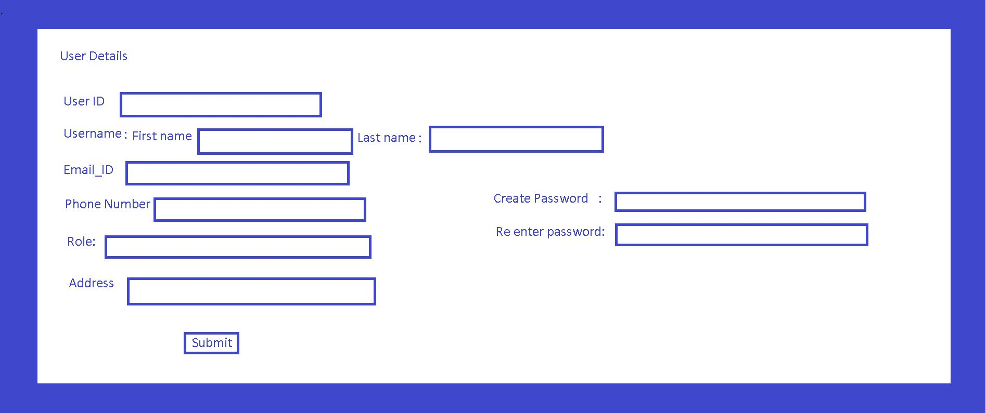

1. Creating task

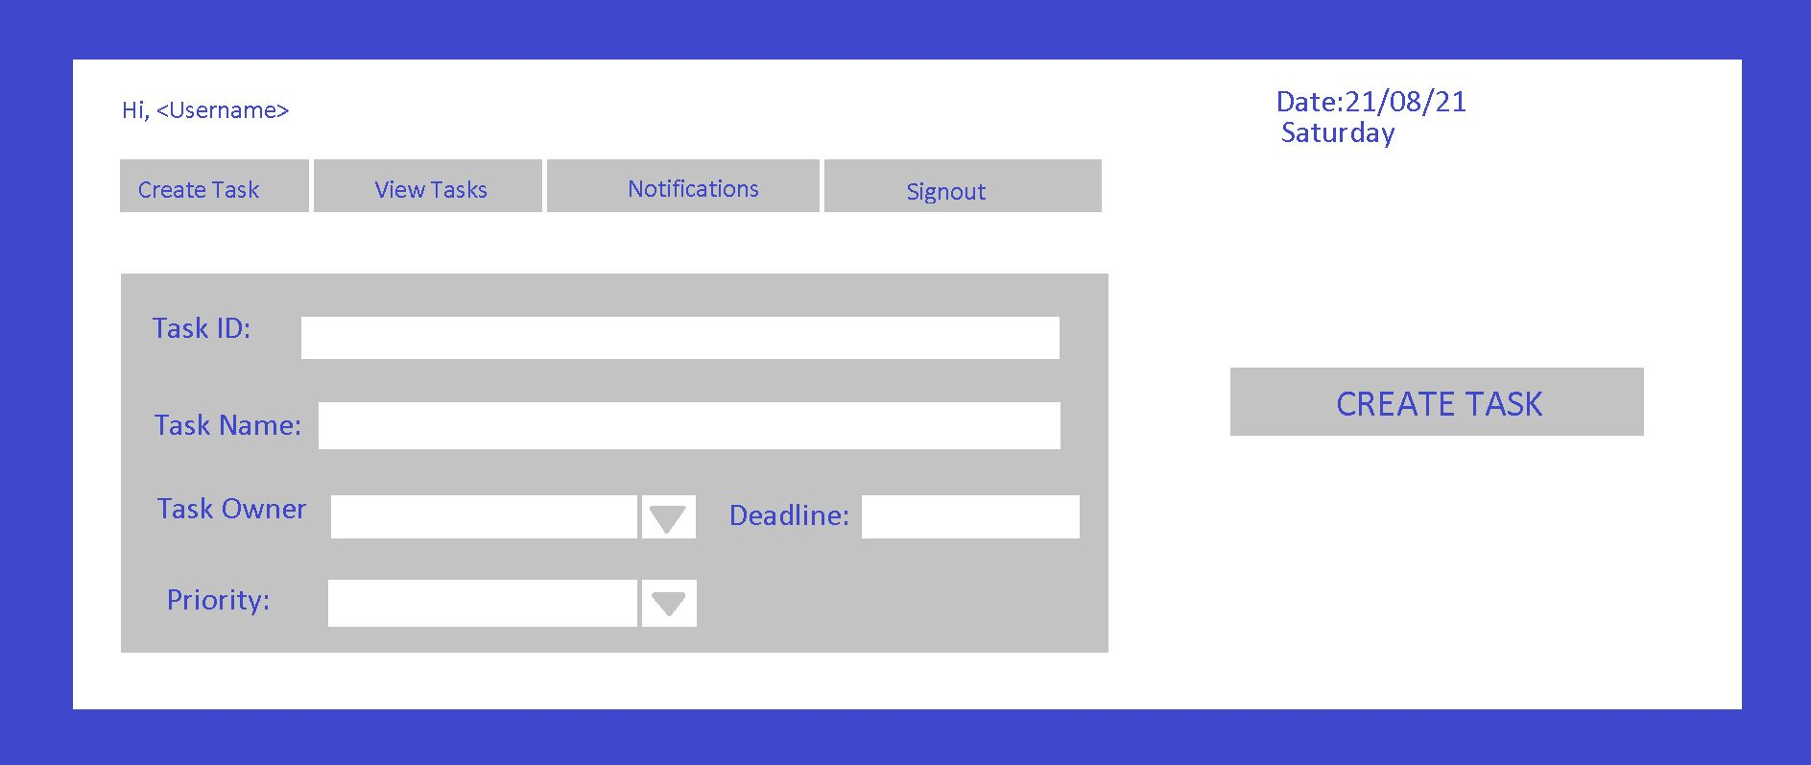

There is a horizontal menu to navigate between “create task”,”View Task”,”Notification” and “signout”.

When Create task option is chosen from the menu, the following can be done.

User creates task by entering the id and name. Assigns a task owner , by choosing a name from the drop down menu. Enters the deadline. The user also sets the priority (ex:high,moderate,low).

After clicking the Create task button, a notification will be sent to the respective task owner and also the task will be added to a list

1. View tasks from the list

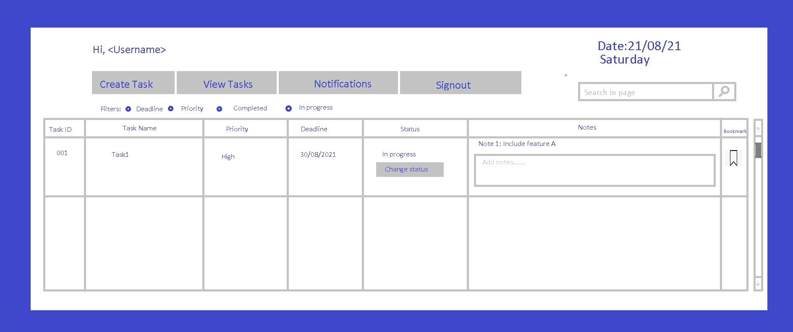

When view tasks option is clicked, this page opens up.

The user has the option of filtering the tasks. The status can be changed by pressing the “change status “button. New notes can be added in the notes column whenever necessary. The tasks can be bookmarked too